Chapter 21: Paired Samples and Blocks

1. **Paired t-test:**

**2006 Winter Olympics Example:**

1. Open the data file (2006 Winter Olympics.csv).
2. Select the **Data** tab $⟹$**Data Analysis**.

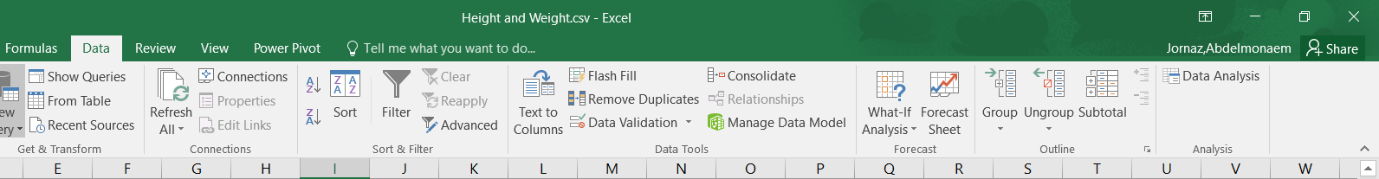

1. The **Data Analysis** box will appear, select **t-Test: Paired Two Sample for Means** and click **OK**.

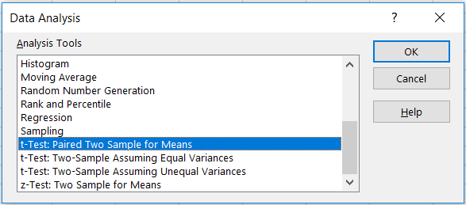

1. The **t-Test: Paired Two Sample for Means** box will appear. Click on **Variable 1 Range** and select the first variable (Inner Time). Click on **Variable 2 Range** and select range of the second variable (Outer Time). Select Labels to till Excel that the first row of the data is a label. Click on **Output Range** and select any empty cell to present the results on it, then click **OK**.

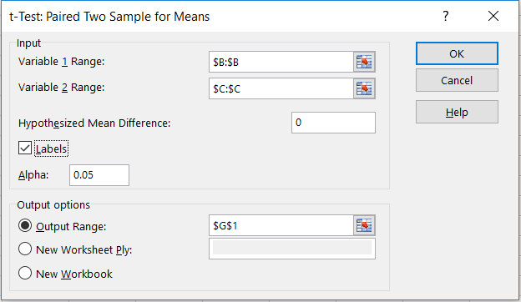

1. The result is

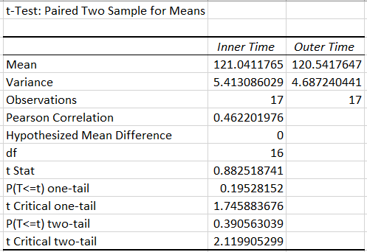

P-value

Test statistics

1. **Confidence Intervals for Matched Pairs:**

**Ages of Husbands and Wives Example:**

1. Open the data file (Ages of Husbands and Wives.csv).

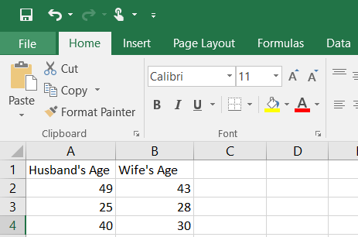

1. Create a new variable (Difference) to calculate the difference between the observations of the two variables.

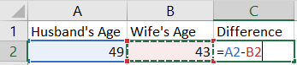

Double click on the small box in the lower right side of cell C1 to get the difference for all of the cells.

1. Select the **Data** tab $⟹$**Data Analysis**.



1. The **Data Analysis** box will appear, select **Descriptive Statistics** and click **OK**.

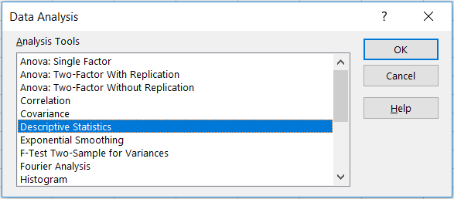

1. The **Descriptive Statistics** box will appear. Click on **Input Range** and select the Difference. Select **Grouped By:** Columns. Select **Labels in the first row** to till Excel that the first row of the data is label. Select **Summary Statistics** and **Confidence Level for Mean** and set the confidence level you need (95% in this example). Click on **Output Range** and select any empty cell to present the results on it, then click **OK**.

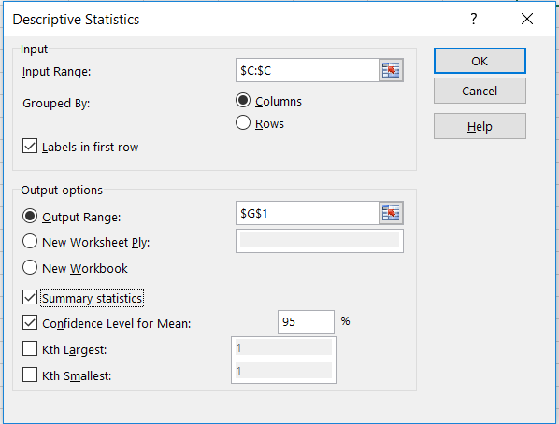

1. The result is

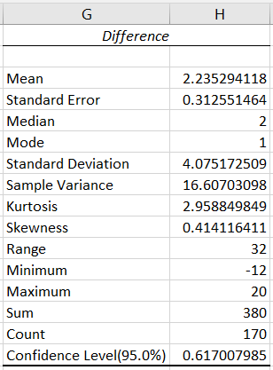

The **Confidence Level (95.0%)** is the margin error, so we can use it to construct the confidence interval.







**Note:** You may also use **CONFIDENCE.T** function to calculate the margin of error.



where **alpha $\left(α\right)$** is the significant level. A significant level 0.05 indicates a 95% confidence level.

**standard_dev** is the standard deviation of the sample.

**size** is the sample size (n).

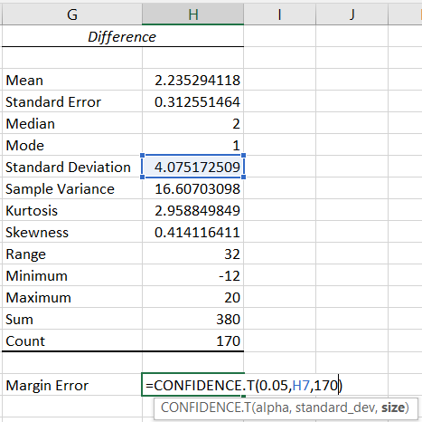

1. Select any empty cell and set “**= Mean -** **Confidence Level (95.0%)”** for the lower confidence interval bound. “**= Mean +** **Confidence Level (95.0%)”** for the upper confidence interval bound

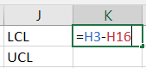

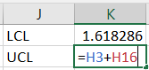

1. The 95% confidence interval is: (1.62, 2.85)

